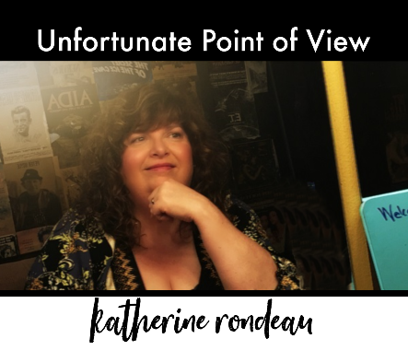
KATHERINE RONDEAU
Unfortunate Point of View
12/15/18

FOR IMMEDIATE RELEASE
PHILADELPHIA, PA – Philly folk singer-songwriter Katherine Rondeau (Ron-DOE) has embraced the big, bold sound inspired from the Folk Revival on her latest release UNFORTUNATE POINT OF VIEW. Katherine’s second album is a hand-crafted collection of original and classic folk songs ranging from full-throttle protest songs to plaintive love ballads and high-energy tunes that would feel at home from Greenwich Village to Nashville and beyond.
With Katherine’s powerful lead vocals and rhythm guitar in the forefront, the album features musical support from a group of acclaimed musicians including glorious harmonies from Joe Jencks (Brother Sun), lead guitar from Eric Lambert and Ross Bellenoit, fiddle and mandolin from Eric Lee, cello from Michael G. Ronstadt, and drums and percussion from Tommy Geddes.
The album opens with the driving self-penned protest song “Coming Soon (if not Today),” inspired by Katherine’s take on the need to “speak the truth to power” in dangerous political times. “My grandfather was a German immigrant,” said Katherine, “and he saw the rise of fascism grow “legally” in his country. He always wondered how good people could allow such horrible things to happen. I feel echoes of his history today, and there are no simple answers to his question.”
The strong up-temp sound continues on “Wishing,” a bright folk-grass number that speaks to “wishing for things that never will come true.” Straight out of Nashville comes the aching murder ballad “Natchez Trace” with searing violin as the wronged woman’s “dagger turns to scarlet.”
Katherine also pays tribute to her folk idols with covers of several classic songs. “What’s That I Hear” is a hopeful Phil Ochs song recorded with an upbeat mandolin and lush harmonies arranged and performed by Joe Jencks. You “can hear that whistle blowing” on Bob Dylan’s “Tonight I’ll Be Staying Here with You” in a version that feels as warm as a glowing fireplace in winter. The last cut on the album is Katherine’s rich alto take on Joni Mitchell’s “Urge for Going” that has already made it on the International Folk DJ Charts as part of radio promoter Hudson Harding’s 2018 holiday CD The Longest Night of the Year Volume 1.
But a classic folk record with a title track inspired by science fiction? The song UNFORTUNATE POINT OF VIEW was inspired by themes explored in the film Guardians of the Galaxy 2, although Katherine didn’t realize it at the time. “My husband is a science fiction nut,” she says, “and he dragged me to the movie begrudgingly. But I cried three times in the theater – the interweaving stories of love and loss, and making a family from friends really resonated with me. But it wasn’t until my second viewing a few months later that I realized that the first verse of this tender song was written from the perspective of a mohawk-finned, blue-skinned bounty hunter!”
Self-produced with the assistance of multiple Grammy award winning engineer Glenn Barratt at Morningstar Studios in East Norriton, PA, Katherine knew from the very beginning of the project that she wanted to craft a record totally authentic to her live performances. Her big bold voice and inspiring performance style captivates audiences from the Delaware Valley to parts ranging from New Hampshire to Alabama. UNFORTUNATE POINT OF VIEW establishes Katherine Rondeau as a major voice on the national folk scene.
UNFORTUNATE POINT OF VIEW is available at www.katherinerondeau.com/upov as well as on major digital music services including iTunes, Amazon, and Google Music. She is currently touring in support of the new album at venues and festivals throughout the US (selected dates below).
For more information visit http://www.katherinerondeau.com
Tour Dates:
December 19 — New York, NY — Urban Stages (Christine Lavin and Friends)
Jan 4, 2019 — Garden City, NY — Garden Stage Coffee House
Jan 6, 2019 — Bethlehem, PA — Godfrey Daniels (Lehigh Valley Album Release Show)
Jan 20, 2019 – Succasunna, NJ – Investors Bank Theater (supporting Scott Wolfson & Other Heroes)
March 1, 2019 — Teaneck, NJ — Ethical Brew (supporting Ellis Delaney)
April 5, 2019 — Marblehead, MA — Me and Thee Coffeehouse (supporting Bill Staines)

