Introducing Folk Powerhouse Katherine Rondeau

Katherine Rondeau is a full-throttle singer-songwriter who focuses her passion for classic folk music through a thoroughly modern lens. After bursting onto the Philly folk scene in 2015, she was quickly recognized for her rich, bold voice and engaging performance style. Katherine’s new album Unfortunate Point of View features seven original and four folk classics, and the music community has taken notice – with four consecutive months on the Folk DJ charts, including #4 album and #1 original song in January 2019, and 9 weeks on the North American College and Community (NACC) top 30 Folk charts.
Katherine’s sound is an organic blend of folk, blues, and mountain music. Her voice – strong, soulful, warm – rings out like a bell on a clear summer’s night. “There is a warmth and a strength to Rondeau’s singing and to her music in Unfortunate Point of View that keeps me looking forward to the next cut on the CD, Bill Revill, WESU-FM
Katherine’s music really shines in her live performances – her big, bold voice and engaging style have made her a festival favorite. After making her festival debut at the Philadelphia Folk Festival (PFF) in 2015, Katherine began spreading her music to large audiences throughout the region. “I love the energy of live performance, picking up the audience’s energy and focusing it right back into my set. It’s been great to be a repeat performer at so many great festivals– and to see fans keep coming back for more.”
Unfortunate Point of View features contributions from an outstanding cast of musicians – luminous harmonies (and bouzouki) from Joe Jencks (Brother Sun), rousing fiddle and mandolin from Eric Lee, haunting cello from Michael G. Ronstadt – plus guitar work from Katherine’s frequent touring partner Eric Lambert. Iconic folk DJ Rich Warren of The Midnight Special program at WFMT in Chicago selected Katherine as one of his artists of the week for three weeks running, confirming her status as an artist worthy of national attention. He and many other DJs are spinning her music week after week, and heaping their praises on her efforts.
Katherine is establishing herself as a regional touring artist, expanding from the NJ/NY/PA area to New England, the Southeast, and Midwest. Her current 2019 tour schedule includes venues from Maryland to Chicago to North Carolina and beyond. Look for her next musical release in 2020.
Press/Reviews
Katherine Rondeau, through her first two, self-released works, has established herself as a national force in folk music. However, after listening to Unfortunate Point of View I'd say she is really much more. She's just good. Audiophilereview.com
The title cut on Unfortunate Point of View shows Katherine at her finest, pairing both cello and banjo – (trust me, it’s sublime), on a cut about looking back at love, in a sound that harkens back to the ’70s work of Joni Mitchell. Ink19
Finding that sweet spot where folk meets blues, this is a smoking, all around set that delivers the goods with ease. Midwest Record
Katherine's amazing voice makes the rafters ring! Her smooth, rich alto, combined with outstanding songwriting and guitar work, captivates the audience wherever she goes. Energy is her middle name. Wanda Adams Fischer, WAMC-FM / Albany, NY
Katherine Rondeau’s voice holds authenticity and soul in every note. Modern folk music in the finest tradition of the form. Justin Helmer, Frets, KVSC-FM / Minneapolis, MN
With her powerfully rich voice to lead the way, Katherine Rondeau delivers a rootsy performance that harkens back to the best of the Folk Revival with a modern style. Ron Olesko, WFDU-FM

Unfortunate Point of View is steeped in Southern grit and style. Sometimes bluesy, sometimes wistful, Katherine's soulful voice takes us on a journey down winding back roads through the heart of Natchez Trace and beyond. Abby Parks, WLJS-FM

Awards
2018 Folk Alliance Midwest (FARM) Folk DJ Showcase
2018 Falcon Ridge Folk Festival Emerging Artist Showcase
2017 Northeast Regional Folk Alliance (NERFA) Semi-Formal Showcase
2017 Northeast Regional Folk Alliance (NERFA) Folk DJ Showcases

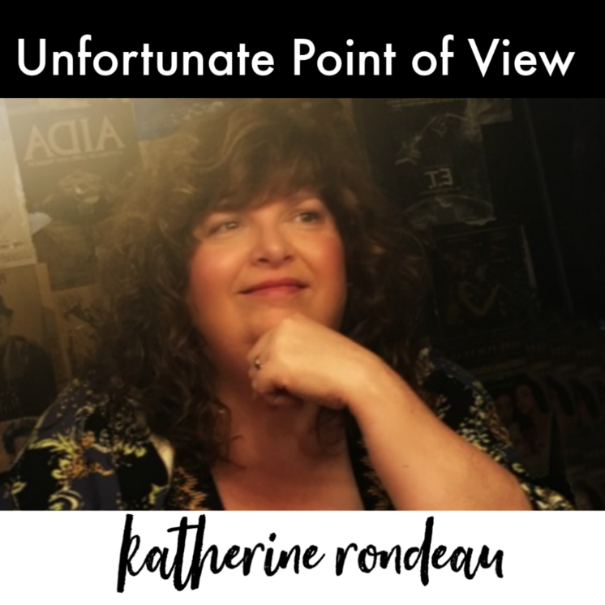
Selected Venues/Festivals
2019 – Godfrey Daniels, PA
2019 – Garden Stage Coffee House, NY
2019 – Sellersville Theater, PA
2019 – me&thee, MA
2018 – John Platt’s On Your Radar, NY
2018 – World Café Live, PA
2018 – Isis Music Hall, NC
2018 – Burlap and Bean, PA
2018 – Sundilla House Concerts, AL
2018 – Chestnut Tree House Concerts, CT
2017 – Hurdy Gurdy Folk Club, NJ
2018 – Falcon Ridge Folk Festival
2015, 2016, 2017 – Philadelphia Folk Festival
2017, 2018 – Huntington NY Folk Festival
2016, 2018 – Delmarva Folk Festival
2015, 2017 – Ladybug Music Festival

Contact
showrondeau@gmail.com
609-432-9127
www.katherinerondeau.com
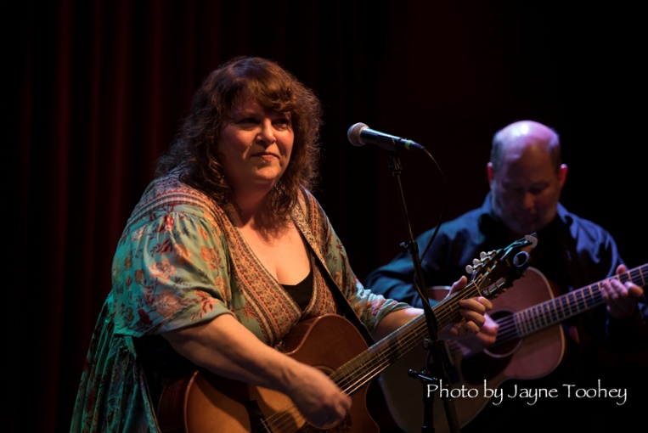
Instagram.com/katherinerondeau
Facebook.com/katherinerondeau sings
Facebook.com/thekatherinerondeau
Folk radio promotion by Hudson Harding

