Introducing Folk Powerhouse Katherine Rondeau

Katherine Rondeau is a full-throttle singer-songwriter who focuses her passion for classic folk music through a thoroughly modern lens. After bursting onto the Philadelphia folk scene in 2015, she was quickly recognized for her rich, bold voice and warm, engaging performance style.
And what a voice it is! Iconic Folk DJ Rich Warren of WFMT’s Midnight Special program may have said it best: “She possesses an amazing set of pipes and knows how to use them.” Katherine’s soaring alto moves effortlessly through all facets of the folk genre – the haunting cry of an Appalachian-inspired murder ballad, a powerful, passionate call for social justice, a honey-warmed love song, and a roof-raising singalong that inspires the whole audience to “join the choir!”
Her January 2019 release Unfortunate Point of View debuted at #4 with the #1 original song, and is one of only two albums charting for nine straight months on the Folk Alliance Folk DJ charts (sharing the distinction with Smithsonian Folkways artists Lula Wiles). More than 20 Folk DJs across the country listed Katherine's self-produced album on their weekly top ten lists, and the accolades don’t stop there. “Katherine Rondeau’s voice holds authenticity and soul in every note. Modern folk music in the finest tradition of the form.” Justin Helmer, KVSC
Introducing herself to audiences at esteemed festivals and venues around the country has become one of Katherine’s favorite pastimes! She’s a three-time performer at the Philadelphia Folk Festival, and has appeared at many others including Musikfest, Spring Gulch, Susquehanna, Gottagetgon’, the Ladybug Festival, and Groove in the Grove, to name a few. She’s also headlined at Godfrey Daniels, World Café Live, Isis Music Hall, Garden Stage Coffeehouse, and two esteemed Folk DJ run concert series – Rich Warren’s Folkstage and John Platt’s On Your Radar, both in 2019.
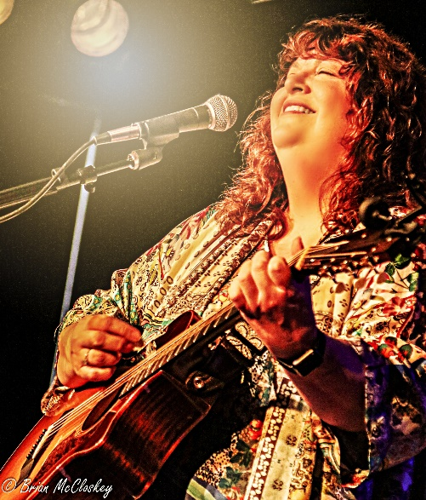
Katherine Rondeau has a powerful voice and stage presence. Joy emanates as she invites the audience to experience the songs along with her which makes for a warm and appreciative community from the first note to the last.” Kathy Sands-Boehmer, me&thee coffeehouse
In 2018 Katherine was selected as a Falcon Ridge Folk Festival Grassy Hill Emerging Artist, and she has received multiple juried showcases at Folk Alliance regional conferences across the country, including a repeat Semi-Formal showcase at November 2019’s Northeast Regional Folk Alliance conference. “Katherine Rondeau is a bold voice in the folk world and Unfortunate Point of View showcases her strengths as a dynamic songwriter and singer.” Chris Kocher, WHRW
Katherine has established herself as a regional touring artist, expanding from the NJ/NY/PA area to New England, the Southeast, and Midwest. Her 2019 tour schedule includes venues from New York to Chicago, with 2020 dates already set from Pennsylvania to Indiana. Whether sharing stories of love lost and found, calling out robust anthems of peace and justice, or reimagining classic songs from the Folk Revival, Katherine Rondeau has earned her place at the folk table.

Press/Reviews

Katherine Rondeau, through her first two, self-released works, has established herself as a national force in folk music. However, after listening to Unfortunate Point of View I'd say she is really much more. She's just good. Audiophilereview

With her powerfully rich voice to lead the way, Katherine Rondeau delivers a rootsy performance that harkens back to the best of the Folk Revival with a modern style. Ron Olesko, WFDU-FM

Katherine Rondeau has subtly added to her sound on her second release, Unfortunate Point of View, adding an old-time, bluegrass touch with mandolin and banjo, and like her New Hope Chateau from 2016, it’s her songwriting and strong voice that carries the day. Ink19
Katherine's amazing voice makes the rafters ring! Her smooth, rich alto, combined with outstanding songwriting and guitar work, captivates the audience wherever she goes. Energy is her middle name. Wanda Adams Fischer, WAMC-FM / Albany, NY
Awards
2019 Northeast Regional Folk Alliance (NERFA) Semi-Formal Showcase
2018 Folk Alliance Midwest (FARM) Folk DJ Showcase
2018 Falcon Ridge Folk Festival Emerging Artist Showcase
2017 Northeast Regional Folk Alliance (NERFA) Semi-Formal Showcase
2017 Northeast Regional Folk Alliance (NERFA) Folk DJ Showcases

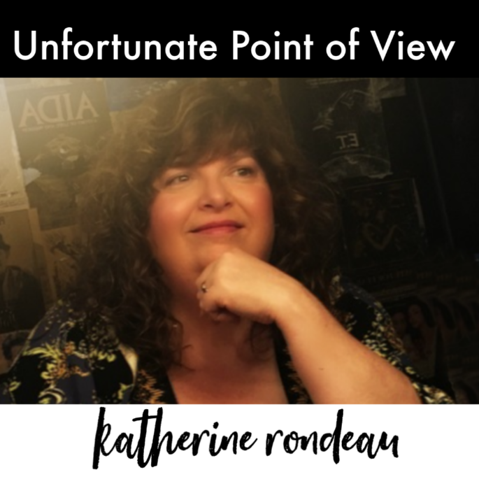
Selected Venues/Festivals
2019 – Rich Warren’s Folkstage, IL
2019 – Two Way Street Coffeehouse, IL
2019 – Godfrey Daniels, PA
2019 – Garden Stage Coffee House, NY
2018 – John Platt’s On Your Radar, NY
2018 – World Café Live, PA
2018 – Isis Music Hall, NC
2018 – Burlap and Bean, PA
2018 – Sundilla House Concerts, AL
2018 – Chestnut Tree House Concerts, CT
2017 – Hurdy Gurdy Folk Club, NJ
2019 – GottagetGon Festival
2019, 2017, 2015 – Ladybug Music Festival
2018 – Spring Gulch Folk Festival
2018, 2017 – Huntington NY Folk Festival
2018, 2016 – Delmarva Folk Festival
2017, 2016, 2015 – Philadelphia Folk Festival

Contact
showrondeau@gmail.com // 609-432-9127 // www.katherinerondeau.com Instagram.com/katherinerondeau // Twitter.com/katherinerondeau
Facebook.com/katherinerondeausings (general) // Facebook.com/thekatherinerondeau (artist)
Youtube: tinyurl.com/rondeauvideo
Folk radio promotion by Hudson Harding

